**Task 1: Flattening Transactions XML file**

import os  
os.environ['PYSPARK_SUBMIT_ARGS'] = '--jars file:///C:/Users/shaws/Documents/Zeyobron/ExternalLibraries/*.jar pyspark-shell'  
  
from pyspark import SparkContext,SparkConf  
from pyspark.sql import *  
from pyspark.sql.types import *  
from pyspark.sql.functions import *  
import urllib.request  
  
def main():  
 sc = SparkContext(master="local", appName="test")  
 sc.setLogLevel("Error")  
 spark = SparkSession.builder.getOrCreate()  
  
 rawDF= spark.read.format("com.databricks.spark.xml")\  
 .option("rowTag","Transaction")\  
 .load("file:///C:/Users/shaws/Documents/Zeyobron/DataFiles/transactions.xml")  
   
 #-----------------------------------Flattening of XML Data-----------------------------------  
 cleansedDF= rawDF.selectExpr("*","ControlTransaction.*")\  
 .withColumnRenamed("_Version","ControlTransaction_Version")\  
 .selectExpr("*","OperatorSignOff.*")\  
 .selectExpr("*","OperatorID.*")\  
 .withColumnRenamed("_OperatorName","OperatorID_OperatorName") \  
 .withColumnRenamed("_VALUE", "OperatorID_VALUE")\  
 .selectExpr("*","RetailTransaction.*")\  
 .withColumnRenamed("_Version","RetailTransaction_Version")\  
 .withColumn("LineItem",explode(col("LineItem")))\  
 .selectExpr("*","LineItem.*")\  
 .withColumnRenamed("_EntryMethod","LineItem_EntryMethod") \  
 .withColumnRenamed("_weightItem", "LineItem_weightItem") \  
 .selectExpr("*","PerformanceMetrics.*")\  
 .withColumn("Total",explode(col("Total")))\  
 .selectExpr("*","Total.*")\  
 .withColumnRenamed("_TotalType","Total_TotalType")\  
 .withColumnRenamed("_VALUE","Total_VALUE")\  
 .selectExpr("*","Sale.*")\  
 .withColumnRenamed("_ItemType","Sale_ItemType")\  
 .selectExpr("*","Tax.*")\  
 .withColumnRenamed("_TaxDescription","Tax_TaxDescription")\  
 .withColumnRenamed("_TaxID","Tax_TaxID")\  
 .selectExpr("*","Tender.*")\  
 .withColumnRenamed("_TenderDescription","Tender_TenderDescription")\  
 .withColumnRenamed("_TenderType","Tender_TenderType")\  
 .withColumnRenamed("_TypeCode","Tender_TypeCode")\  
 .selectExpr("*","Itemizers.*")\  
 .withColumnRenamed("_FoodStampable","Itemizers_FoodStampable")\  
 .withColumnRenamed("_Itemizer6","Itemizers_Itemizer6")\  
 .withColumnRenamed("_Itemizer8","Itemizers_Itemizer8")\  
 .withColumnRenamed("_Tax1","Itemizers_Tax1")\  
 .withColumnRenamed("_VALUE","Itemizers_VALUE")\  
 .selectExpr("*","MerchandiseHierarchy.*")\  
 .withColumnRenamed("_DepartmentDescription","MerchandiseHierarchy_DepartmentDescription")\  
 .withColumnRenamed("_Level","MerchandiseHierarchy_Level")\  
 .withColumnRenamed("_VALUE","MerchandiseHierarchy_VALUE")\  
 .selectExpr("*","POSIdentity.*") \  
 .withColumnRenamed("_POSIDType","POSIdentity_POSIDType") \  
 .selectExpr("*","Authorization.*") \  
 .withColumnRenamed("_ElectronicSignature","Authorization_ElectronicSignature") \  
 .withColumnRenamed("_HostAuthorized","Authorization_HostAuthorized") \  
 .drop(col("ControlTransaction"))\  
 .drop(col("OperatorSignOff")) \  
 .drop(col("OperatorID"))\  
 .drop(col("RetailTransaction"))\  
 .drop(col("LineItem"))\  
 .drop(col("PerformanceMetrics"))\  
 .drop(col("Total"))\  
 .drop(col("Sale"))\  
 .drop(col("Tax"))\  
 .drop(col("Tender"))\  
 .drop(col("Itemizers"))\  
 .drop(col("MerchandiseHierarchy"))\  
 .drop(col("POSIdentity"))\  
 .drop(col("Authorization"))  
  
 #cleansedDF.printSchema()  
 cleansedDF.show(5,False)  
  
 record_c = cleansedDF.selectExpr("COUNT(1) AS COUNT").collect()[0]["COUNT"]  
  
 print("Total columns count: ",len(cleansedDF.columns))  
 print("Total Records count: ", record_c)  
  
if __name__ == '__main__':  
 main()

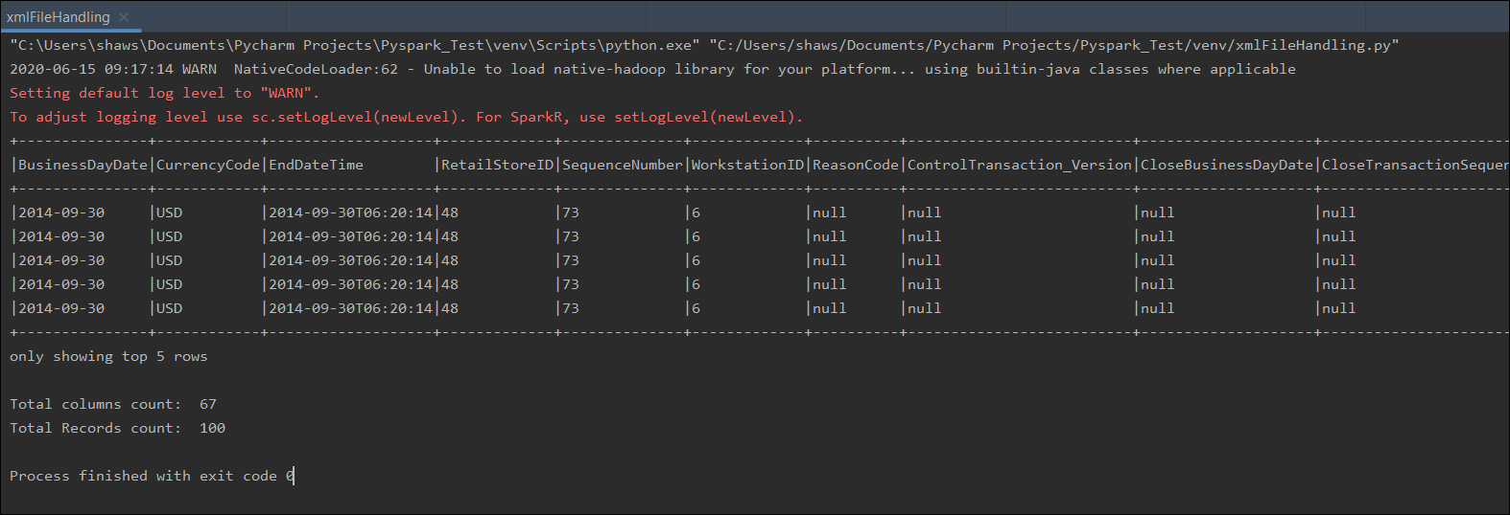

**Task 2: Read data from an URL and store in AVRO $ JSON format**

import os  
os.environ['PYSPARK_SUBMIT_ARGS'] = '--jars file:///C:/Users/shaws/Documents/Zeyobron/ExternalLibraries/*.jar pyspark-shell'  
  
from pyspark import SparkContext,SparkConf  
from pyspark.sql import *  
from pyspark.sql.types import *  
from pyspark.sql.functions import *  
import urllib.request  
  
def main():  
 sc = SparkContext(master="local", appName="test")  
 sc.setLogLevel("Error")  
 spark = SparkSession.builder.getOrCreate()  
  
 # -----------------------------Read data from URL-----------------------------  
 url = 'https://randomuser.me/api/0.8/?results=10'  
 response = urllib.request.urlopen(url)\  
 .read().decode('utf-8')  
 json_str = str(response)  
  
 #-----------------------------String to Spark RDD-----------------------------  
 json_list = ''.join(json_str.split()).split()  
 rawRDD = sc.parallelize(json_list)  
  
 # -------------------------Spark RDD to Spark Dataframe-----------------------  
 json_df = spark.read.json(rawRDD)  
 #json_df.printSchema()  
  
 # ------------------------------Flattening JSON-------------------------------  
 df = json_df \  
 .withColumn("results",explode(col("results"))) \  
 .selectExpr("nationality","results.*","seed","version") \  
 .selectExpr("nationality","user.*","seed","version") \  
 .selectExpr("username","nationality","cell","dob","email","gender","location.*",  
 "md5","name.*","password","phone","picture.*","registered",  
 "salt","sha1","sha256","seed","version") \  
 .withColumn("username",regexp_replace(col("username"),"[0-9]",""))  
  
 df.show(20,False)  
  
 # ------------------------------Save into JSON-------------------------------  
 df.coalesce(1).write.format("json").mode("overwrite").save("file:///C:/Users/shaws/Documents/Zeyobron/pyspark/2020-14-06/task2/json")  
  
 # ------------------------------Save into JSON-------------------------------  
 df.coalesce(1).write.format("com.databricks.spark.avro").mode("overwrite").save("file:///C:/Users/shaws/Documents/Zeyobron/pyspark/2020-14-06/task2/avro")  
  
 print("write completed")  
  
if __name__ == '__main__':  
 main()

**Remove NUMERICALS from Column: username**

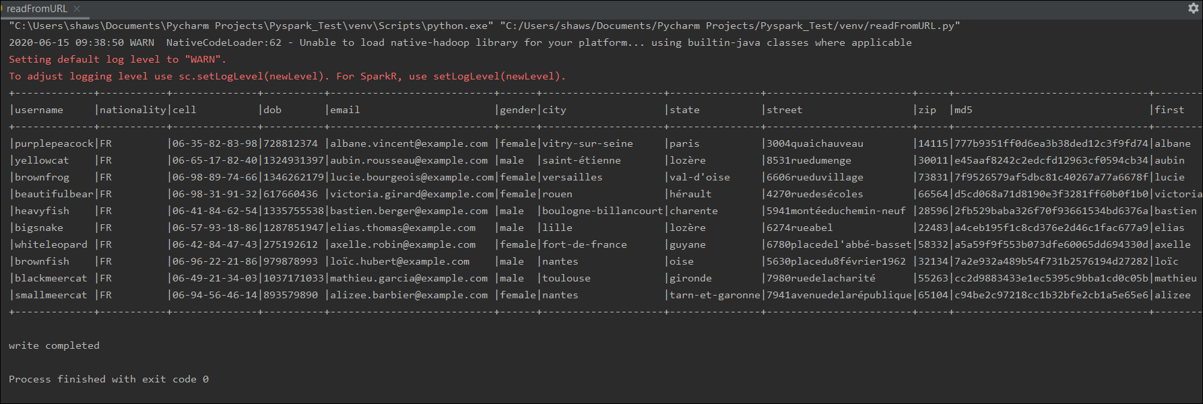

**JSON**

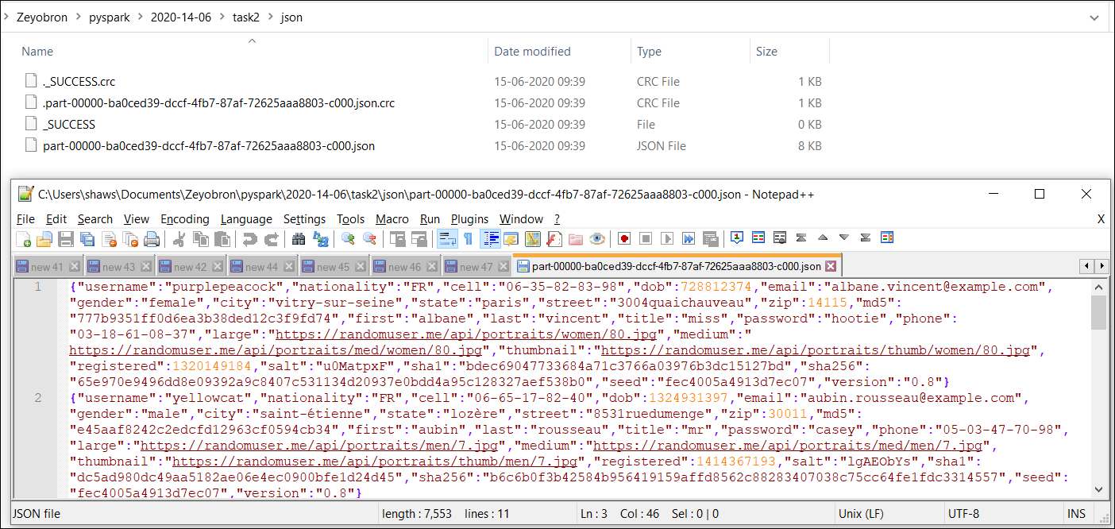

**AVRO**

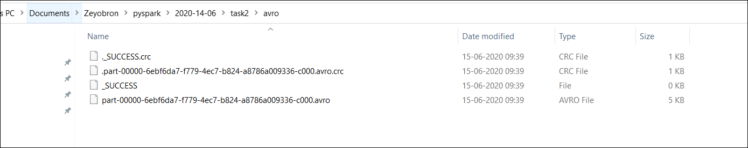

**Task 3: Read data from URL and load ZIPCODE into MySQL table**

import os  
os.environ['PYSPARK_SUBMIT_ARGS'] = '--jars file:///C:/Users/shaws/Documents/Zeyobron/ExternalLibraries/mysql-connector-java-5.1.49.jar pyspark-shell'  
  
from pyspark import SparkContext,SparkConf  
from pyspark.sql import *  
from pyspark.sql.types import *  
from pyspark.sql.functions import *  
import urllib.request  
  
def main():  
 sc = SparkContext(master="local", appName="test")  
 sc.setLogLevel("Error")  
 spark = SparkSession.builder.getOrCreate()  
 #.config("spark.driver.extraClassPath","C:/Users/shaws/Documents/Zeyobron/ExternalLibraries/mysql-connector-java-5.1.49.jar")\  
  
 # -----------------------------Read data from URL-----------------------------  
 url = 'https://randomuser.me/api/0.8/?results=40'  
 response = urllib.request.urlopen(url)\  
 .read().decode('utf-8')  
 json_str = str(response)  
  
 #-----------------------------String to Spark RDD-----------------------------  
 json_list = ''.join(json_str.split()).split()  
 rawRDD = sc.parallelize(json_list)  
  
 # -------------------------Spark RDD to Spark Dataframe-----------------------  
 json_df = spark.read.json(rawRDD)  
 #json_df.printSchema()  
  
 # ------------------------------Flattening JSON-------------------------------  
 df = json_df \  
 .withColumn("results",explode(col("results"))) \  
 .selectExpr("nationality","results.*","seed","version") \  
 .selectExpr("nationality","user.*","seed","version") \  
 .selectExpr("location.zip") \  
  
  
 df.show(5,False)  
  
 # ------------------------------Check Table Count-------------------------------  
 count_v = spark.read.format("jdbc").option("url","jdbc:mysql://localhost:3306/practicedb").option("driver", "com.mysql.jdbc.Driver")\  
 .option("user", "root").option("password", "admin").option("dbtable", "(SELECT COUNT(1) AS COUNT FROM practicedb.randomuser_zip) t1_alias").load()  
  
 x = count_v.collect()[0]["COUNT"]  
 print("Total Record Count: ", x)  
   
 # ------------------------------Table Load-------------------------------  
 if (x >= 100):  
 df.write \  
 .format("jdbc") \  
 .option("url", "jdbc:mysql://localhost:3306/practicedb") \  
 .option("driver", "com.mysql.jdbc.Driver") \  
 .option("user", "root") \  
 .option("password", "admin") \  
 .mode("overwrite") \  
 .option("dbtable", "randomuser_zip") \  
 .save()  
 else:  
 df.write \  
 .format("jdbc") \  
 .option("url", "jdbc:mysql://localhost:3306/practicedb") \  
 .option("driver", "com.mysql.jdbc.Driver") \  
 .option("user", "root") \  
 .option("password", "admin") \  
 .mode("append") \  
 .option("dbtable", "randomuser_zip") \  
 .save()  
  
  
if __name__ == '__main__':  
 main()

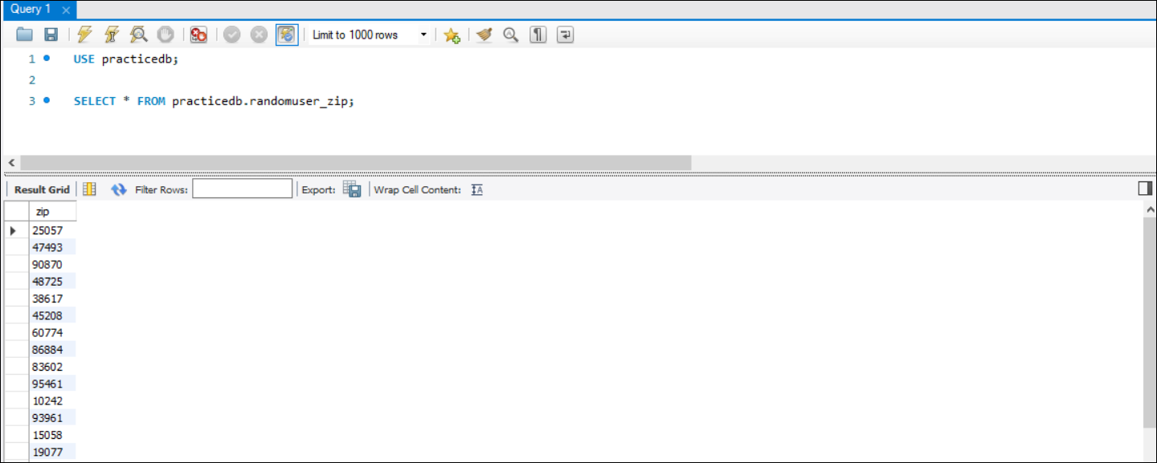

**Task 4: Flattening a File**

from pyspark import SparkContext,SparkConf  
from pyspark.sql import *  
from pyspark.sql.types import *  
from pyspark.sql.functions import *  
  
def main():  
 sc = SparkContext(master="local", appName="test")  
 sc.setLogLevel("Error")  
 spark = SparkSession.builder.getOrCreate()  
  
 rawDF = spark.read.format("csv").option("Delimiter","~").option("header","true").option("inferSchema","true")\  
 .load("file:///C:/Users/shaws/Documents/Zeyobron/DataFiles/PractitionerLatest.txt")  
  
 #--------------------------------------Split Column to Explode into Multiple Rows--------------------------------------  
 explodedDF= rawDF.withColumn("PROV_PH_DTL",split(col("PROV_PH_DTL"),"\\$").cast("array<string>"))\  
 .withColumn("PROV_PH_DTL",explode_outer(col("PROV_PH_DTL")))\  
 .withColumn("PROV_ADDR_DTL", split(col("PROV_ADDR_DTL"), "\\$").cast("array<string>")) \  
 .withColumn("PROV_ADDR_DTL", explode_outer(col("PROV_ADDR_DTL"))) \  
 .withColumn("PROV_PH_DTL", regexp_replace(col("PROV_PH_DTL"), "^[ \\t]+|[ \\t]+$", ""))\  
 .withColumn("PROV_ADDR_DTL", regexp_replace(col("PROV_ADDR_DTL"), "^[ \\t]+|[ \\t]+$", ""))  
  
 # --------------------------------------Split a Column to Convert into Multiple Columns--------------------------------------  
 cleansedDF= explodedDF.withColumn("PROV_PH_DTL",split(col("PROV_PH_DTL"),"\\|"))\  
 .withColumn("PROV_PH_DTL1",col("PROV_PH_DTL").getItem(0))\  
 .withColumn("PROV_PH_DTL2", col("PROV_PH_DTL").getItem(1))\  
 .withColumn("PROV_PH_DTL3", col("PROV_PH_DTL").getItem(2))\  
 .withColumn("PROV_PH_DTL4", col("PROV_PH_DTL").getItem(3))\  
 .drop(col("PROV_PH_DTL"))\  
 .withColumn("PROV_ADDR_DTL", split(col("PROV_ADDR_DTL"), "\\|")) \  
 .withColumn("PROV_ADDR_DTL1", col("PROV_ADDR_DTL").getItem(0)) \  
 .withColumn("PROV_ADDR_DTL2", col("PROV_ADDR_DTL").getItem(1)) \  
 .withColumn("PROV_ADDR_DTL3", col("PROV_ADDR_DTL").getItem(2)) \  
 .withColumn("PROV_ADDR_DTL4", col("PROV_ADDR_DTL").getItem(3)) \  
 .withColumn("PROV_ADDR_DTL5", col("PROV_ADDR_DTL").getItem(4)) \  
 .withColumn("PROV_ADDR_DTL6", col("PROV_ADDR_DTL").getItem(5)) \  
 .withColumn("PROV_ADDR_DTL7", col("PROV_ADDR_DTL").getItem(6)) \  
 .withColumn("PROV_ADDR_DTL8", col("PROV_ADDR_DTL").getItem(7)) \  
 .withColumn("PROV_ADDR_DTL9", col("PROV_ADDR_DTL").getItem(8)) \  
 .withColumn("PROV_ADDR_DTL10", col("PROV_ADDR_DTL").getItem(9)) \  
 .withColumn("PROV_ADDR_DTL11", col("PROV_ADDR_DTL").getItem(10)) \  
 .withColumn("PROV_ADDR_DTL12", col("PROV_ADDR_DTL").getItem(11)) \  
 .withColumn("PROV_ADDR_DTL13", col("PROV_ADDR_DTL").getItem(12)) \  
 .drop(col("PROV_ADDR_DTL"))  
  
 rawDF.filter(col("PROV_ID")=="MAC000001896").select("PROV_ID","PROV_PH_DTL","PROV_ADDR_DTL").show(20,False)  
 cleansedDF.filter(col("PROV_ID")=="MAC000001896").select("PROV_ID",  
 "PROV_PH_DTL1","PROV_PH_DTL2","PROV_PH_DTL3","PROV_PH_DTL4",  
 "PROV_ADDR_DTL1","PROV_ADDR_DTL2","PROV_ADDR_DTL3","PROV_ADDR_DTL4",  
 "PROV_ADDR_DTL5","PROV_ADDR_DTL6","PROV_ADDR_DTL7","PROV_ADDR_DTL8",  
 "PROV_ADDR_DTL9","PROV_ADDR_DTL10","PROV_ADDR_DTL11","PROV_ADDR_DTL12",  
 "PROV_ADDR_DTL13")\  
 .show(20,False)  
  
if __name__ == '__main__':  
 main()

